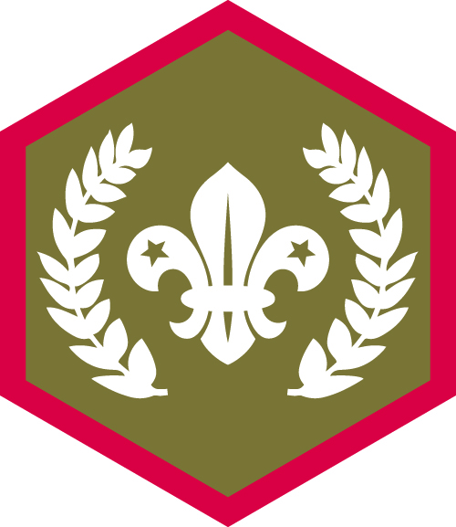
Chief Scout Award - Gold

Name ___________________________________

- Earn six activity or staged activity badges of your choice. They could be badges you gain outside of your normal meetings or ones you’ve achieved through your programme.

Activity or Staged Badge

- Complete the nine challenge awards. These are:

Challenge Award | Awarded
World Challenge Award
Skills Challenge Award
Creative Challenge Award
Outdoors Challenge Award
Adventure Challenge Award
Expedition Challenge Award
Teamwork Challenge Award
Team Leader Challenge Award
Personal Challenge Award

Logged on OSM: Awarded:

