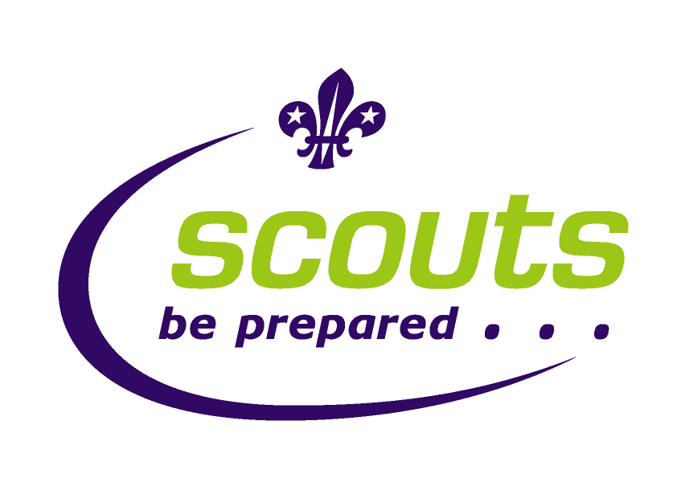
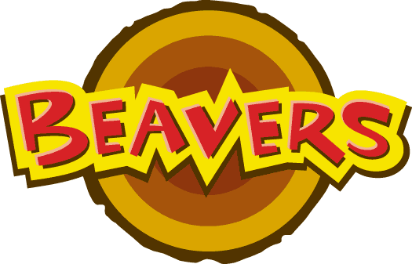


Code of Conduct

The Leaders and Scouts of the 138th Glasgow Scout Group will work together to promote good behaviour in the Group whilst having a programme, which is both challenging and fun.

- All Beavers, Cubs and Scouts are expected to come to meetings regularly

- All Beavers, Cubs and Scouts will join in games and activities, work as a team and help each other.

- All Beavers, Cubs and Scouts will show respect to Leaders, Parents and other visitors to the Group.

- Leaders, Beavers, Cubs and Scouts agree to listen to each other and be respectful.

- No one makes fun of anyone else because of his or her colour, religion, abilities or disabilities.
- Bullying is not acceptable.

- No one will make a noise in quiet times like prayers or while game rules are being explained.

- All Beavers, Cubs and Scouts will demonstrate a high standard of behaviour to the wider community.

