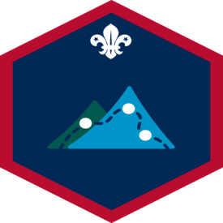
Expedition Challenge

Name ___________________________________

- Take part in either an expedition or an exploration over two days with at least three other Scouts. This should include a night away at a campsite or hostel.

- Take an active part in planning the expedition. Do any training you need and be well prepared. Training should include:
  - planning a route, including rest and meal stops. Being able to work out how long it should take you to travel that route.

  - choosing suitable equipment for an expedition. You might consider tents, stoves, rucksacks, walking equipment, emergency equipment, first aid kit, wet weather gear, appropriate food and a
camera.

  - navigation and using things like maps and timetables for your expedition. You might want to brush up on using an Ordnance Survey or similar map, a compass, a GPS device, a street map or A-Z, and rail or bus timetables.

  - knowing what to do in an emergency.

- During the expedition or exploration:
  - play a full part in the team
  - use a map or other navigation device to keep track of where you are
  - cook and eat at least one hot meal
  - do a task, investigation or exploration as agreed with your leader.

- Produce an individual report or presentation within the three weeks following your expedition. You could present your work as a project, performance, video recording, oral presentation, blog or website.

Logged on OSM: Awarded:

